Scoil Phobail Béal Átha H-Amhnais
__________________________________
BALLYHAUNIS COMMUNITY SCHOOL

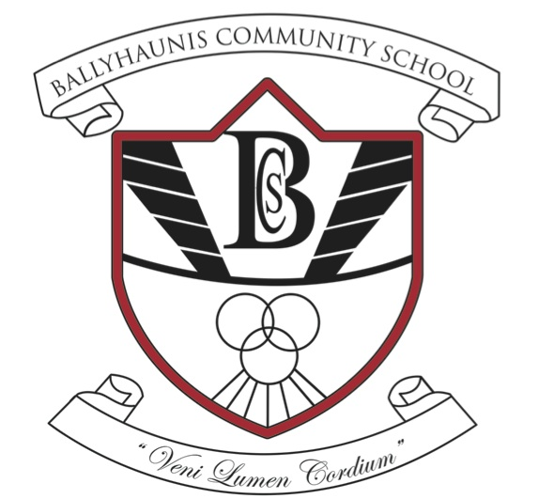

Invitation to Tender
Percent for Art Commission

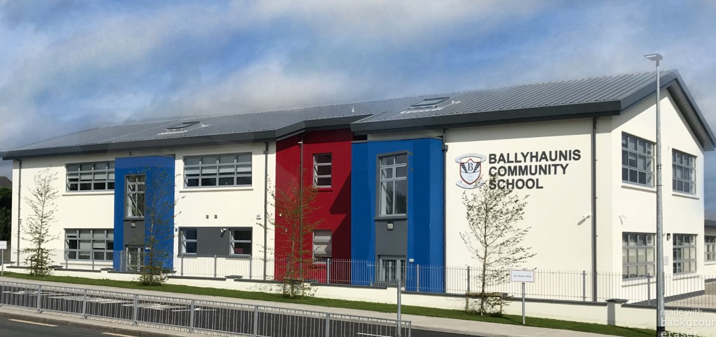Deadline for Stage 1 Submissions: 24/01/2020

Budget: €40,000

Project Overview
The Board of Management of Ballyhaunis Community School wishes to commission a public artwork under the Percent for Art Scheme, funded by the Department of Education and Skills. The school is currently nearing the completion of a major extension and refurbishment of its facilities. The current date for completion is the Spring of 2020.

Overview of the School
Ballyhaunis Community School was founded in 1977 when the Mercy Convent, Vocational School and St. Patrick’s college amalgamated. The Mercy Convent Secondary School opened in 1954 and was in the grounds of the present St. Joseph’s Primary School, Bridge St. Ballyhaunis. The Vocational School was located where Manor Brook Housing Estate now stands and was built in 1941. St. Patrick’s College was on the site of the playing areas at the front of the present school and was opened in 1941. The present Community School caters for all the second level needs of the students in the catchment area and offers a wide curriculum reflecting the traditions of the previous schools. The school also offers people in the community the opportunity to pursue Post Leaving Certificate Courses.

Mission Statement
“We in Ballyhaunis Community School are committed to fostering the holistic development of each individual.
We aim to promote equality for all and respect for one another and our environment and to give each person the opportunity to reach his/her potential.
While valuing our traditions we encourage innovative curricula to achieve these aims in a safe caring and ordered manner in partnership within the school, with parents and with the broader community.”
In the context of this mission statement our broad goals as a school are:
- To create a safe and healthy living and learning environment where each student can grow, feel comfortable, establish positive relationships and achieve to the best of his/her abilities;
- To provide a safe and challenging teaching and learning environment for our students that values excellence;
- To provide experiences that encourage creativity, personal development, and helps develop students' problem solving, decision making, and critical thinking skills.
- To recognise that uniqueness of each student, to value their gifts and to welcome him/her in an inclusive manner for who he/she is;
- To challenge our students to discover, and to explore to the best of their talents and abilities;
- To develop in our student’s independence, responsibility, and self-discipline;
- To provide a school environment that promotes positive human values, that is enriched by Christian beliefs and that operates based on due respect for the beliefs of all.
- That emphasises the rights and responsibilities of each student as well as all other members of this school community;
- To encourage tolerance, respect, and understanding of other people;
- To promote the development of a school curriculum that meets the needs of our students.
- To encourage families to be active participants in the school community.

Background of Ballyhaunis
Ballyhaunis lies in an area of great historical importance, with one of the highest concentrations of megalithic monuments in the West of Ireland. It is a town in County Mayo, Ireland. It is at the crossroads of the N60 and N83 National secondary roads and on the railway line linking Dublin to Westport and Ballina.
It is thought that the town grew up around St Mary's Augustinian Friary (popularly referred to as "the Abbey"), which was founded in 1348, according to local tradition. The town and its hinterland contain a number of megalithic monuments. There are numerous ringforts, souterrains, burial mounds, church sites, wedge tombs, crannogs (lake dwellings) and fulachta fiadha (ancient cooking sites).
However, this is a radically changing ethnic landscape. According to the 2011 Census, no where else is as multi-cultural as Ballyhaunis. Welcome to Ireland’s most cosmopolitan town.

Ballyhaunis has a mixed community where farming, private business and industry are the main sources of employment. The bulk of the town's employment is provided by sizeable steel fabrication and food processing industries, supplying the Irish and overseas markets. Its central location has long made Ballyhaunis an ideal centre of distribution for many businesses and there is also construction, furniture manufacturing and many ancillary construction service providers. Other areas of employment include retail, government, financial and professional services.

There is a network of country lanes around Ballyhaunis for the walking/cycling enthusiast, which lead into areas of great environmental importance. See and appreciate the wonderful flora and fauna of our rich countryside as you stroll along the roads past rolling green fields to the bog roads where birds can be seen in their natural habitat. Within easy reach of Ballyhaunis the Annagh/Mannin valley, Knockbrack, Leow and Scrigg are prime examples of this type of area
Ballyhaunis GAA is the main sporting team in the town, fielding teams in both Gaelic football and hurling. Other sports played in Ballyhaunis include rugby, boxing, cricket, and soccer.
Ballyhaunis is a friendly welcoming town with people who will take the time to stop and talk to you and make you feel welcome.
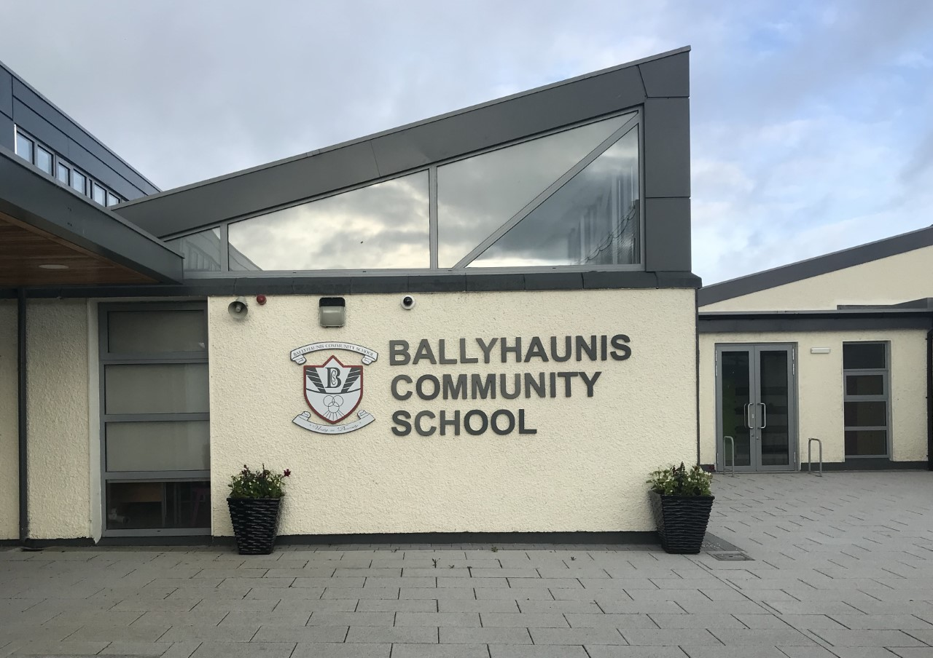
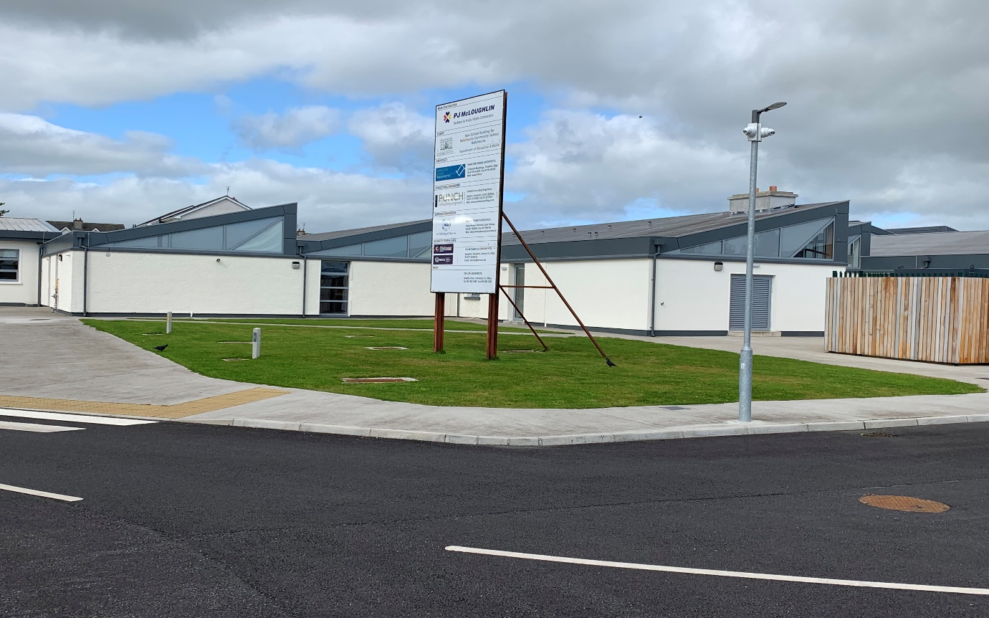
Proposed site for Installation
Commission Brief
We see the Percent for Art Scheme as an opportunity to contribute to our building and school life with a piece of captivating artwork and we are excited to find an artist or collaborative artists to fulfil this brief. Professional artists are invited to be cognisant of our desire to include our staff and children in the creative process, where possible, so a warm and nurturing approach is important to us.

Artists’ proposals are invited to be:
• Sensory, vibrant and imaginative
• Original and innovative
• A stimulating interactive experience for our school community.
• Should show an understanding of our school ethos, daily activities and environs
• Durable, safe and easily maintained (in the case of a physical artwork)
• Value for money

THE COMMISSION
- The commission is open to all art forms for this project, with the proviso that any physical artwork within the grounds of a second level school needs to be robust and have regard for public health and safety.
- The artwork must reflect the ethos and spirit of the school and be cognisant of the location and setting.
- Art work is to be complete by August 2020, subject to agreement between artist and school board of management.

THE COMMISSIONING PROCESS
The selection process for this project will comprise an open competition. All interested professional artists at any stage of their career or experience are welcome to tender.

Selection will be a two-stage process and will be made by a panel, based on the information supplied by the applicant. Outline proposals are required for stage 1.

Stage 1
Applicants must submit
- A plan outlining general ideas for the commission and the artistic concept of the proposed work. (Please limit your response to 1500 words and 10 images)
- An up-to-date C.V.
- Selection of examples of recent work (web links or e-file)
- Examples of previous commissions and/or references
- Submissions to be made by email to the school at:
principal@ballyhauniscs.ie
- All submissions will be assessed, and a shortlist will be formed.
- The commissioners shall not be liable for any costs or expenses in respect of successful or unsuccessful applicants for the initial stage.

Stage 2
- The shortlisted candidates who move to stage two will be paid a concept development fee of €500 (including VAT and all other charges) to submit an outline of their proposal and concept.
- The proposal will include a detailed breakdown of all costs.
- Please note that Ballyhaunis Community School reserves the right to commission at stage two or not to commission from entries received and to re-advertise, directly invite, directly commission or to select more than one submission for commission and to divide the budget accordingly.

The Selection Panel
The Selection Panel will consist of nominees from the school community and an external art expert.

SELECTION CRITERIA
  - Artistic merit
  - Quality of concept
  - Relevance to the spirit, ethos, history and cultural context of the school
  - Clarity and practicality of proposal
  - Value for money
  - Demonstrated ability to carry out the project
  - Long term value and impact

RESPONSIBILITIES OF THE ARTIST
All artists must comply with the necessary Health and Safety Legislation in the design, manufacture, supply, delivery and installation of the work paying particular attention to the challenges created by a secondary school setting. It is the responsibility of the artist(s) to deliver the work on time and in budget. The successful artist(s) will be required to be Garda vetted.

BUDGET
The budget is €40,000 this is to cover design, supply and installation of art works, inclusive of all associated costs including VAT.

INSURANCE
Artists will be required to have Public Liability insurance cover for work they have to undertake on site and Employers Liability insurance cover for any person that they undertake to bring on site as part of the design or implementation phase of the project.

TAX CLEARANCE
The successful artist(s) must provide the school with a tax clearance certificate. Full details of the proposed artwork as well as the artist’s name and the value of the commission must be furnished by the school to the building unit of the Department of Education and Skills.

Project timeline

December 2019/Early January 2020 | Site Visits
Friday 24th January, 2020, 12pm | Deadline for stage 1 proposals
Week of 10th February 2020 | Applicants will be notified of results of shortlisting and those shortlisted will be invited to make Stage 2 proposals.
Friday 13th March 2020, 12pm | Deadline for Stage 2 Submission
Week of Monday, 30th March, 2020 | Shortlisted Artists will be notified of the results of the competition
April/May 2020 | Commissioned work to be started.
August 2020 | Works to be completed.

