Per Cent Art Commission

Scoil an Athar Tadhg, Carraig na bhFear, Co. Cork

Stage 1
Artists’ Briefing

Budget: Total budget for the commission is €47,000, including all artist expenses and V.A.T.

Deadline for submissions for Stage 1: 5pm, September 13, 2022

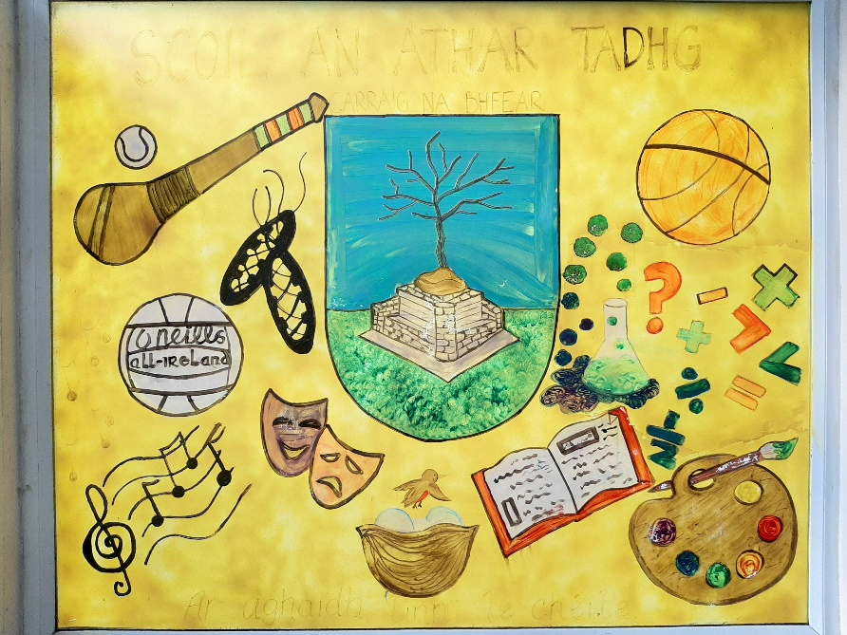
Background
Carraig na bhFear
Carraig an bhFear is a rural village situated six miles north of Cork City. Following from the construction of a hundred or so houses in the early years of the new millennium Carraig na bhFear is now home to 700 families approx., many of these families are employed in the vast array of industry in Cork City. There is a strong emphasis on agricultural activities in the parish with dairy farming to the fore.
The area is synonymous as the birthplace of some of the most important poets of the Gaelic tradition particularly in the eighteenth and nineteenth century when it was said to rival Louvain School in the production of poetry and religious literature. The patronage of the McCarthy’s of Muskerry Family and their castle just outside the village greatly contributed to the strength of the Gaelic tradition in the area.
The life and work of these poets was honoured and celebrated with the opening of Faiche na bhFilí on 16th of September in 1962. The opening was performed by President Eamon de Valera in what is considered locally to be one of the greatest occasions in living memory. This celebration was the culmination of the work of the local people under the leadership of an tAthar Tadhg Ó Murchú. At the start of the 20th century, Irish was the spoken language in pockets of Carraig na bhFear and it was known as a breac-ghaeltacht to which members of Cork city’s Conradh na Gaeilge used to come out to visit and practice their Gaeilge. Athar Tadhg fostered a great love of the language and cultúr during his time here (1960-1972) which the school continues to promote to the present day.
Current President, Michael D Higgins, returned to rededicate Faiche na bhFilí on the 5th May 2013. On a day when the children of Scoil an Athar Tadhg were central to the celebrations, the president stated that wherever you may go in the world and if asked where you come from you can proudly state, “I come from a place where we honour poets”.
https://www.youtube.com/watch?v=YtrJ4x-AYR

Scoil an Athar Tadhg

Scoil an Athar Tadhg is a mixed rural school situated approximately six miles from Cork City in the village of Carraig na bhFear (T34 N276). There are currently 327 students in the school.
Scoil an Athar Tadhg opened its doors in 1974. The named in memory of former parish priest, an t-Athar Tadhg Ó Murchú. During his time in Carraig na bhFear, Athar Tadhg spearheaded the building and unveiling of Faiche na bhFillí. At the time the building of Scoil an Athar Tadhg was sanctioned by the Department of Education on the condition that the three existing schools in the parish, Scoil na mBuachaillí and Scoil na gCailiní in the centre of the village along with Scoil an Glaise Bhuí, three miles north of the village, would amalgamate.
Our school community and the people of the parish have always and continue to share a strong bond. When President de Valera visited in 1962 the proclamation was read by two sixth class pupils. At the unveiling of a newly commissioned stain glass window in the Church of the Immaculate Conception, to celebrate the new millennium in 2000, the unveiling was performed by the youngest child in Scoil an Athar Tadhg. The children of the school were once again central in celebrating the visit of President Higgins to Carraig na bhFear in 2013 where they read poems they penned themselves.
The Cultúr Gaelach continues to remain strong in Scoil an Athar Tadhg. The school takes great pride in promoting all aspects of our cherished culture in the promotion of sport, amhránaíocht, ceol agus ár dteanga gaelach. The school community takes tremendous pride in the promotion of all aspects of “An Cultúr Gaelach” through our participation in the annual Scór na bPáistí Competition. Tá gaisce déanta ag páistí na scoile agus morán gradam buaite acu lena gcuid amhránaíochta, Rince Gaelach, aithriseoireacht, ceol úirlise, rince seit agus foirne tráth na gceist thar na blianta.
Through our participation in Sciath na Scol Activities, with the cooperation and support of CLG Carraig na bhFear, all children in Scoil an Athar Tadhg are coached and afforded the opportunity to represent their school in peil Gaelach, iománaíocht agus camógaíocht and have had much success over the years.
The children of Scoil an Athar Tadhg are also regular participants in the Fóras na Gaeilge initiative, Scríobh Leabhar. This project provides the children with the opportunity to write, design and publish their own books in Irish. Cad é mar bhród a bhíonn ar na páistí agus iad ag léamh a leabhar féin, rud a chuireann leis an traidisiún saibhir a d’fhág ár sinsir i gCarraig na bhFear.
The school’s charity CDs, diligently organised by teacher, Joe Hanafin, annually, has raised tens of thousands of euros for local charities close to the school’s heart. It provided children with the opportunity to be involved in the production of a CD. Musicians, such as John Spillane, Jimmy Crowley, Crystal Swing, the Begley sisters and Mick Flannery, have contributed to the high quality cds, along with the wonderful talents and musicianship of the pupils and school community.
Our school, under the patronage of the Bishop of Cork and Ross, is guided by a highly trained staff of 13 Class Teachers, 11 Special Education Teachers, 5 Special Class Teachers, 20 Special Needs Assistants and an Administrative Deputy Principal and Principal. The school community is tremendously proud and supportive of An Neidín, our Autism Spectrum Disorder (A.S.D.) Unit which is attached to our school. It comprises of a Pre- School Early Intervention Class and four other classes. Children from An Neidín are integrated in various classes throughout the mainstream school for varying lengths of time each day. Establishing An Neidín has greatly enhanced our school in many ways. The children of the mainstream school have embraced the opportunities An Neidín has presented to them. They look forward to periods of reverse integration where they have a chance to guide and lead their peers in the ASD Unit through positive engagement. The children of An Neidín are very much central to the kind and caring atmosphere in our school and their contribution to each of our ten charity CDs is something to be cherished by all who support them, parents, siblings, teachers, SNA’s and the entire school community.

The new Scoil an Athar Tadhg

The Commission relates to the Percentage for Art Scheme for Scoil an Athar Tadhg which involves the construction of a new 3,229m² national school for Scoil an Athar Tadhg on a greenfield site consisting of a proposed 14 classroom school building with a 5 classroom Autistic Spectrum Disorder Unit, with 9 special education tuition (resource) rooms arranged over a 2 storey building with a single storey bolt-on projection to the northwest.

The site is accessed from a shared entrance road with the Community Council and GAA Club. The extensive site development works will consist of construction of car parking, bus and car set down facilities, hard surface and grass play areas, soft landscaping, new vehicular and pedestrian site entrances, site boundaries, extensive underground services and ancillary site development including entrance, road outside site boundary, drainage and traffic calming measures on public road.

The building will be finished in painted plastered render, standing seam roof which is grey in colour and grey windows and doors. Please refer to photomontage attached.

The roadside boundary wall is to consist of piers finished in natural stone and low levels walls finished in painted plastered render with selected railings on top.

It is anticipated that the new school building and prepared site will handed over to the client in April 2023.

Vision of the Project

“Wherever you go around the world, you can say, “I come from a place where we honour poets”.

An t-Uachtarán, Michael D. Higgins, May 5th, 2013

The school’s Per Cent Art committee have chosen the above quote to provide the inspiration for the to-be commissioned piece(s) of visual art. This quote eloquently encompasses the rich, cultural past of our community and our future hopes for the children of Scoil an Athar Tadhg as they spread their wings around the world and proudly proclaim they come from Carraig na bhFear.

There are 5 designated potential sites but it is not limited to these. This is to allow the artists the flexibility to interpret the above vision and to respond to the school environment as they deem appropriate. The artwork(s) may be inside and/or outside.

The selection process will take the form of a Two Stage Open Competition. It is open to all interested professional artists at any stage of their career or experience. Selection will be based on the information supplied at Stage 1, establishing the competence of the artists to carry out this commission.

Aims of the Commission

To commission a piece (or complimentary pieces) of visual art to reflect the character and ethos of Scoil an Athar Tadhg.

To fulfil the outlined vision above and enhance the new school building which is at the heart of our community.

To create (a) piece(s) of visual art to engage and inspire the school community now and into the future.

To engage the current pupil and staff population in a meaningful, small scale parallel art project so as to develop and deepen their understanding for the proposed visual art piece(s).

It is expected that the visual art piece(s) will be permanent, durable, easily maintained, child friendly and vandal proof over time.

The artwork may be one or a series of visual artworks.

The artwork may be two or three dimensional.

The artwork should be created in response to one or more of the designated indoor and/or outdoor sites described below or another suitable site within the school campus, as deemed appropriate by the artists.

The resulting artwork(s) should provide a good backdrop for school photos.

The artwork(s) must comply with current Health & Safety standards.

Timeline

The contractor is presently due to handover the building to the Board of Management of Scoil an Athar Tadhg in April 2023. It is envisaged that the School Management will require 2-3 weeks to fit out and occupy the building following handover. The building will be occupied in early May 2023.

Selection Panel

The panel will consist of members of the school’s Per Cent Art Commission organising committee, the Cork Co Council Assistant Arts Officer and Bertie Pope, Project Architect.

Stage 1

Professional artists are invited to send in their proposals to be considered for the project at the first stage of this commission. The closing date for receipt of the Stage 1 completed attached application form, together with supporting documentation and material, is 5pm on September 13, 2022. Applications may be submitted by email (pcas@athartadhg.ie), as per details on the Application Form. Due to the live nature of the construction site it may not be possible to walk through the site but adequate vantage points are afforded from the adjoining public roadway, access roadway and third party lands. There will be a proposed open afternoon for the artists at Stage 2, date to be confirmed. The school will not be liable for any expenses incurred by artists at Stage 1.

The following will be submitted by the artists at Stage 1:

Completed Application Form, including outline and sketch of what they would envisage for this commission based on the above brief (see attached).

CV

Details of recent relevant artworks or past projects along with images, title, year, materials and budget, as appropriate.

Two references from previous projects undertaken.

Stage 2

From the completed applications at Stage 1 the selection committee will choose a shortlist of artists. The short listed artists at Stage 2 will be paid a concept development fee of €350 to work on a more detailed proposal for final selection. A Stage 2 brief will be made available to the shortlisted artists and a site visit would be expected at this stage. There will be a proposed open afternoon for the artists intending to submit to visit the school and the site on a proposed future date. Due to the live nature of the construction site it may not be possible to walk through the site but adequate vantage points are afforded from the adjoining public roadway, access roadway and third party lands. Stage 2 will also see the successful candidate being selected and a contract being agreed upon. It is anticipated that the art project will be complete by April 2023. The artist should demonstrate their ability to fulfil the project within the given timeframe and budget. The artists must be able to produce a tax clearance certificate, the necessary insurance cover, garda vetting and the ability to comply with current health & safety standards. The final timeline will be agreed with the commissioned artist at contract stage.

Criteria for Selection at Stage 1

Scoil an Athar Tadhg, Carraig na bhFear, Co Cork reserves the right not to proceed with any submissions received.

Ability and relevance to meet the vision for the artwork as described in this brief.

Artistic merit of the proposed artwork.

Quality, durability and practicality of the artwork.

Capacity of the artist, based on his/her artistic record or potential, to carry out and complete the proposed visual art commission within the specified timeframe and allocated budget.

Requirement for artist to have due regard to health and safety, to have adequate insurance and meet other relevant statutory issues.

Budget

This Per Cent for Art Scheme is funded by the Department of Education due to the new school building. The total value of the commission, approved by the Department of Education, is €47,000. This includes the costs of materials, all artist’s fees, design development, artist’s insurance, supply and installation, signage, travel costs, all inclusive of VAT, and any other costs incurred in the development and production of the artwork. The artist will be responsible for meeting all of these costs out of the total budget allocated and to see the project to fruition.

Site locations

Under advice from Design Team, there are 4 potential locations externally marked A, B, C (all green areas) and D (on an external wall) and one potential location internally marked E on the lift shaft wall which is 1.8 meters wide X 8 meters high and viewed from the main stair and exiting the GP Hall.
Please refer to attached drawings and photomontage for further details.

Scoil an Athar Tadhg, Carraig na bhFear
Per Cent for Art Scheme Public Art Commission

APPLICATION FORM
(please complete this application form and attach all requested documents and email: pcas@athartadhg.ie by 5pm on September 13, 2022)

N.B. This Form must be included with your submission
Name:__________________________________________
Address:______________________________________________________ _____________________________________________________________ _____________________________________________________________
Tel. No. (Daytime)___________
Email.___________________________

Pre qualification questionnaire (this section must be completed)
1.1 If considered for this appointment, are you in a position to produce promptly a valid tax clearance certificate or C2 certificate from the Revenue Commissioners? Yes No
1.2 If you are a non-resident candidate, are you in a position to provide a statement of suitability on tax grounds from the Revenue Commissioners in Ireland? Yes No
1.3 Are you capable of undertaking a project of approximate value €47,000 over a 6 month period, commencing in October, 2022? Yes No
1.4 Do you presently hold Employers Liability Insurance? Yes No
1.5 If answered “YES” to 1.4, state the value. €__________________
1.6 Do you presently hold Public Liability Insurance? Yes No
1.7 If answered “YES” to 1.6, state the value. €__________________
1.8 If selected for commission you may be required to undergo Garda vetting in line with the school’s Child Protection Policy. Will you be willing to be Garda vetted?. Yes No

Signature. ________________________ Date____________________________

Name of Artist: ____________________________________
Phone number: ____________________________________
Email address:_____________________________________

- Title of Proposal: ______________________________________________

- Summary of Proposal: A brief description of what you intend to create and why. (approx. 50-100 words)

- Summary Description: Please outline your proposed project. (max. of 500 words)

- School engagement: Please outline how you intend to engage the school community in a small scale parallel project. (max 200 words)

- Attach sketches of your proposed project to outline your vision of the artwork(s).

- Outline briefly a draft budget, including artist’s fees, insurance, development and production costs (all inclusive of VAT).

- Outline a proposed timeline- when available to start, project’s stages and date of completion.

- Attach a relevant, up to date CV.

- Attach examples of recent relevant work, including images, title, year, materials and budget, as appropriate

- Please provide two references:
i.
ii.

