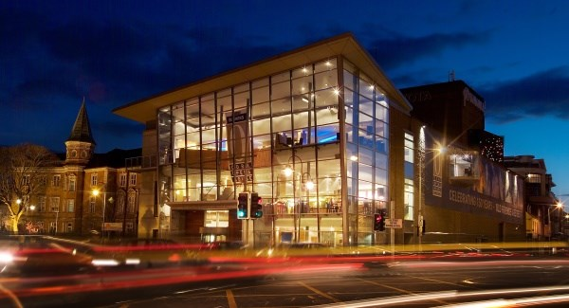

Invitation to Tender
Percent for Art Commission

Cork Opera House
Emmett Place, Cork
www.corkoperahouse.ie

Briefing for Artists

Deadline for submission: Friday 17th January, 2020
Budget: €6,300

Project Overview
The Board of directors of Cork Opera House wishes to commission public artwork(s) under the Per Cent for Art Scheme, funded by the Department of Education and Skills.

Background

Cork Opera House has been part of the life of Cork for over a century and a half. In that time the Opera House has welcomed countless generations of patrons and provided a huge range of entertainment, across a diverse range of genres, including opera, drama, musicals, and comedy, and music from the operatic, jazz and contemporary worlds.

Cork Opera House is the busiest theatre in the country and presents artistic and entertainment productions up to 300 nights annually.
Each year, approximately 230,000 people come visit our house to enjoy entertainment across the entire arts spectrum. In addition to being a performance facility for national and international artists, Cork Opera House produces its own shows including Christmas Panto, Summer Musicals, and both contemporary and concert opera music performances. Cork Opera House also has its own Concert Orchestra, which performs across the year.
The theatre originally was opened in 1855 (known then as The Munster Hall) and over time was expanded and remodelled to accommodate larger audiences.
In 1877 it was renamed as Cork Opera House and was redesigned by CJ Phipps of the Gaiety Theatre in Dublin and London, with the addition of two balconies and an extended stage.

The building was destroyed by fire in 1955. After a ten-year fund raising campaign, to which the people of Cork contributed significantly, was rebuilt in and reopened in 1965 by President Eamon De Valera.
Throughout its history the venue has been host to an incredible number of international performers, including greats of the acting, jazz, opera and contemporary genres.
Cork Opera House has a core team of 40 staff and also employs a large number of freelance artists, theatre practitioners, technical staff, and other creative groups and individuals. It is these people, on both sides of the curtain, that make Cork Opera House the home of world class artistic entertainment in Ireland today.

The Commission
- The commission is open to all art forms for this project, with the proviso that any
physical artwork on or within the facility will be suited to a public environment in structure and finish, having due regard for public health and safety.
- The commission may comprise a single piece of art from one artist or multiple pieces from a number of artists.
- The artwork will reflect the facility, its people and history and be cognisant of the
location and setting.
- Artwork is to be completed during the spring/summer of 2020.

Aim of Commission under the Per Cent for Arts Scheme
- to celebrate the history of Cork Opera House and the people, both on and off the stage, who have contributed to creating and sustaining this iconic Cork arts house. The piece should strive to represent the synergy that is created on our stage, with a clear acknowledgement of the many individuals and characters that have contributed to this process over the years.

Site Location
- Cork Opera House occupies a dominant location in Emmet Place, in the city centre. The preference is for an internal artwork installation, but external installations will be considered if they have significant merit and compliment the external façade and approaches to the house. However, it should be noted that the opportunity to install art on the external areas of the building is very limited, and artistic concepts which may require city authority/planning permissions will not be entertained.
Internally there are several possible locations for any artwork within the building. Photographs of suggested locations are included at the end of this document, but artists are invited to view all potential areas in the house on an open day which will be held on Monday December 9th, 2019, from 10am to 2pm

The Commissioning Process
The selection process for this project will comprise of an open competition. All interested professional artists at any stage of their career or experience are welcome to tender.

Selection will be a two-stage process and will be made by a panel, based on the information supplied by the applicant. Outline proposals are required for Stage 1.

Stage 1
Applicants must submit
- A plan outlining general ideas for the commission and the artistic concept of the proposed work. (Please limit your response to 1500 words and 10 images)
- An up-to-date C.V.
- Selection of examples of recent work (web links or e-file)
- Examples of previous commissions and/or references
- Submissions to be made by email to the theatre at: pfinn@corkoperahouse.ie
- All submissions will be assessed, and a shortlist will be formed.
- The commissioners shall not be liable for any costs or expenses in respect of successful or unsuccessful applicants for the initial stage.

Stage 2
- The shortlisted candidates who move to stage two will be paid a concept development fee of €200 (including VAT and all other charges) to submit an outline of their proposal and concept.
- The proposal will include a detailed breakdown of all costs.
- Please note that Cork Opera House reserves the right to commission at Stage Two or not to commission from entries received and to re-advertise, directly invite, directly commission or to select more than one submission for commission and to divide the budget accordingly.

The Selection Panel
The Selection Panel will consist of nominees from the theatre and an external
artistic consultant.

Selection Criteria
  - Artistic merit
  - Quality of concept
  - Relevance to the historical and cultural parameters of the artistic brief
  - Clarity and practicality of proposal
  - Value for money
  - Demonstrated ability to carry out the project
  - Long term value and impact

Responsibilities of the Artist
All artists must comply with the necessary Health and Safety Legislation in the design,
manufacture, supply, delivery and installation of the work paying particular attention to the challenges created by a theatre setting. It is the responsibility of the artist(s) to deliver the work on time and in budget.

Budget
The budget is €6,300; this is to cover design, supply and installation of art works,
inclusive of all associated costs including VAT.

Insurance
Artists will be required to have Public Liability insurance cover for work they have to
undertake on site and Employers Liability insurance cover for any person that they
undertake to bring on site as part of the design or implementation phase of the project.

Tax Clearance
The successful artist(s) must provide Cork Opera House with a tax clearance certificate. Full
details of the proposed artwork as well as the artist’s name and the value of the
commission must be furnished by the theatre to the building unit of the Department of
Education and Skills.

Project Timeline

Monday 9th December 2019 | Open Day for Site Visit
Friday 17th January 2020 | Deadline for Stage 1 proposals
Week ending 31st January 2020 | Applicants will be notified of results of  shortlisting and those shortlisted will be invited to make Stage 2 proposals.
28th February 2020 | Deadline for Stage 2 submission
Week ending of 20th March 2020 | Artists may be invited to meet with selection committee to outline their proposals
April 2020 | Contract/s complete and commissioned work to be started and completed at a date agreed between artist and commissioner.
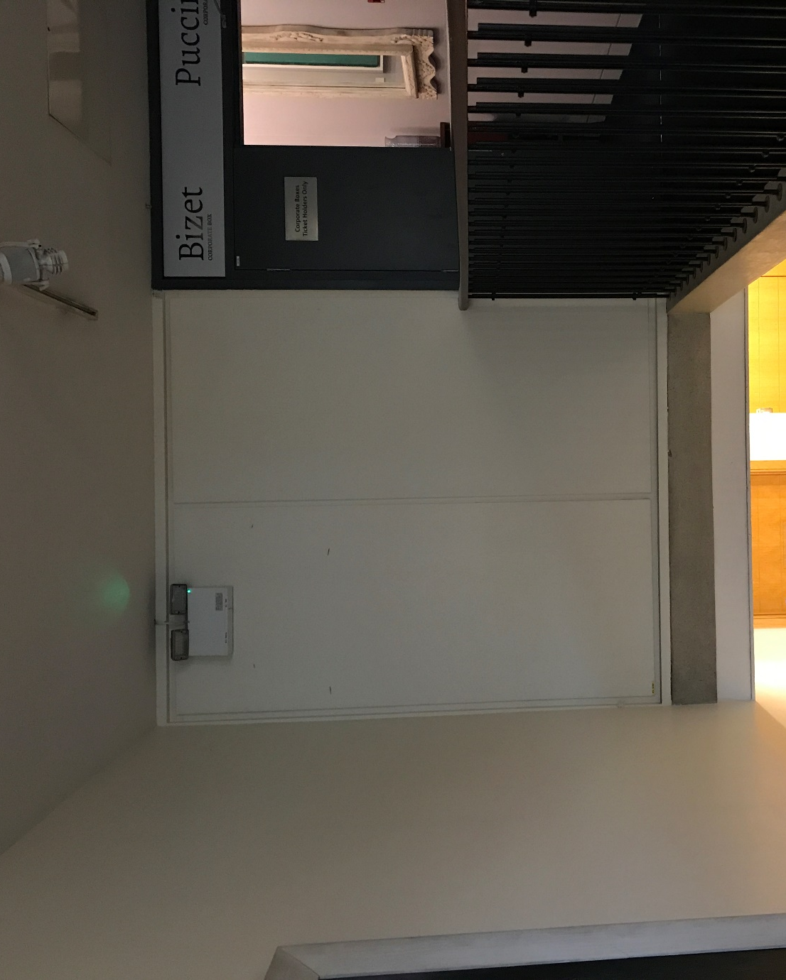
Space over main stairwell
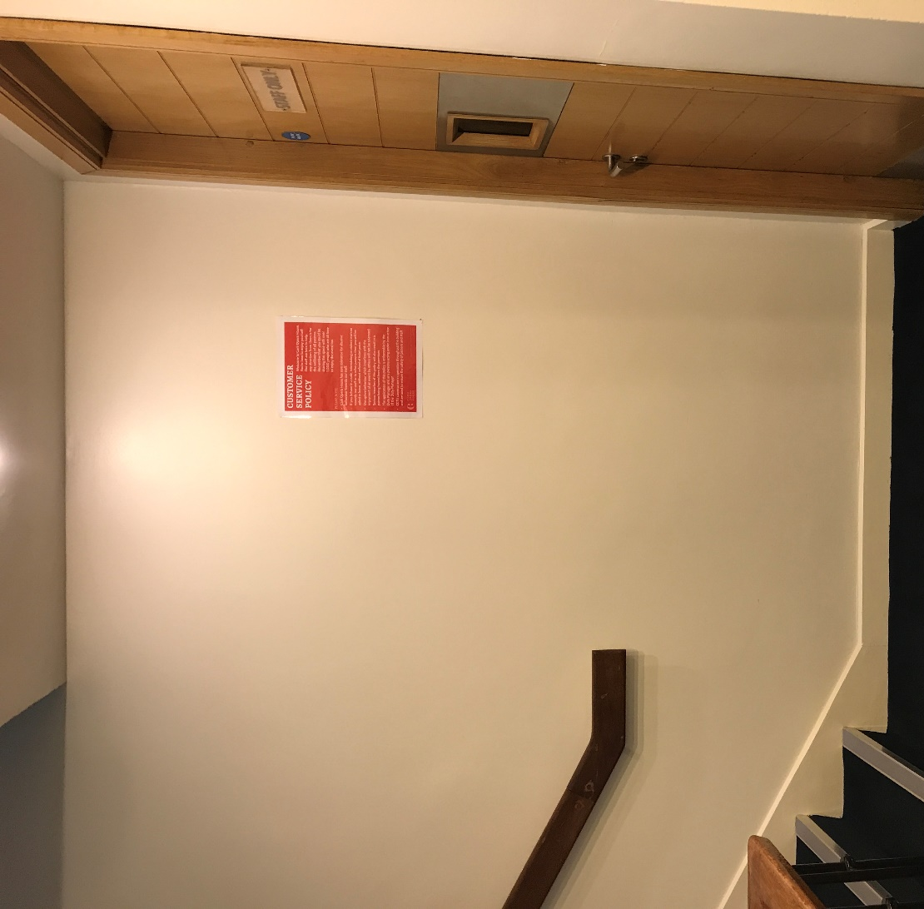
Wall section on main stairs
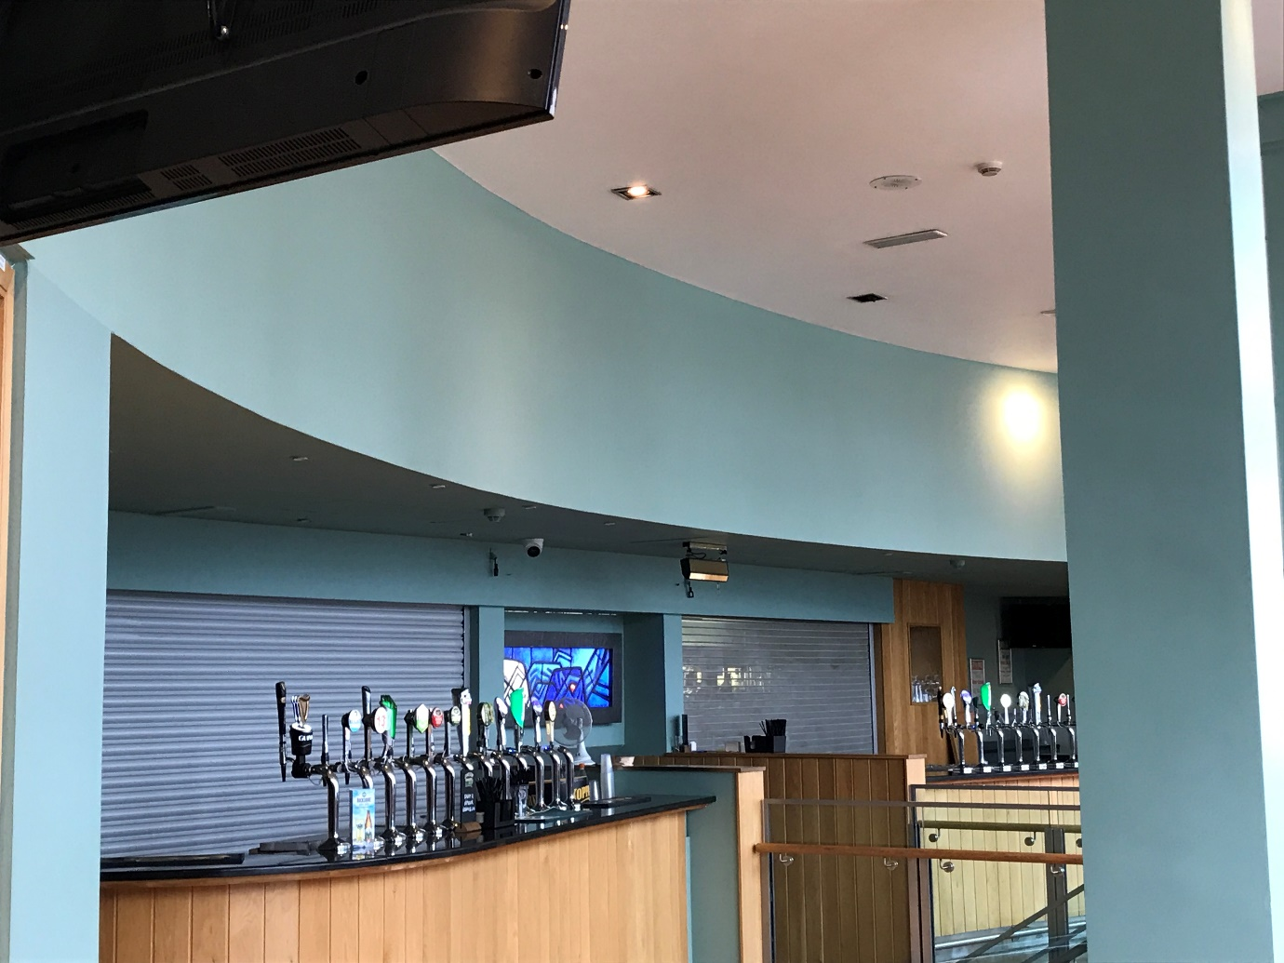
Space over Main Bar
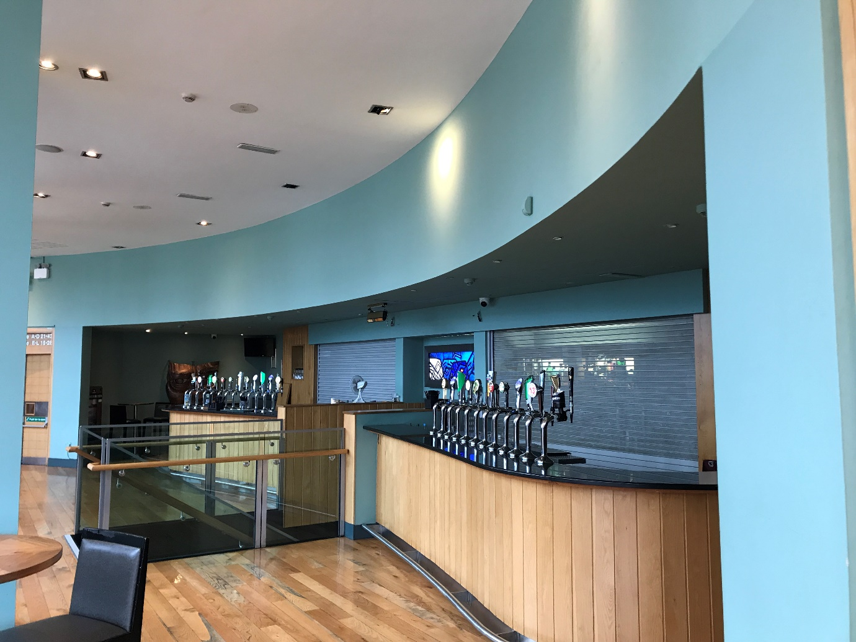
Space over main bar
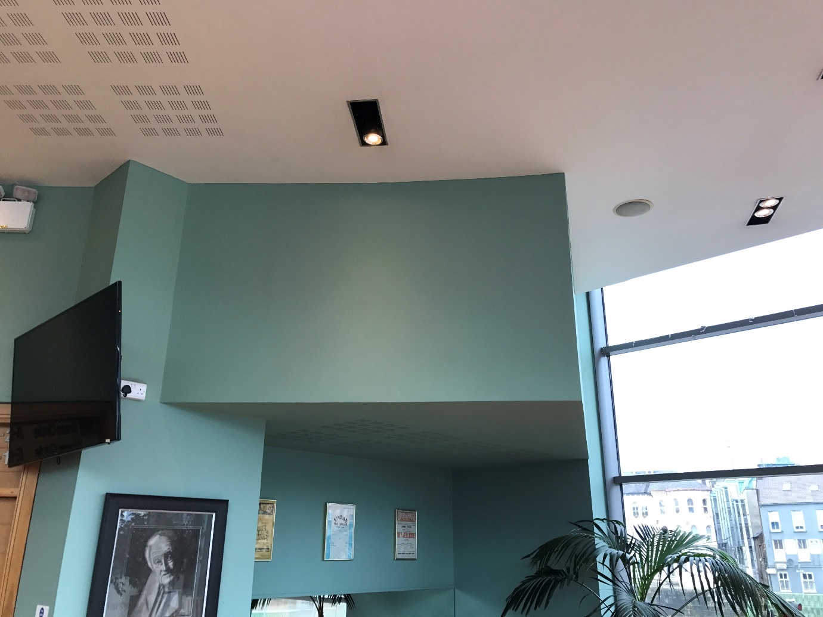
Angled Face within main bar
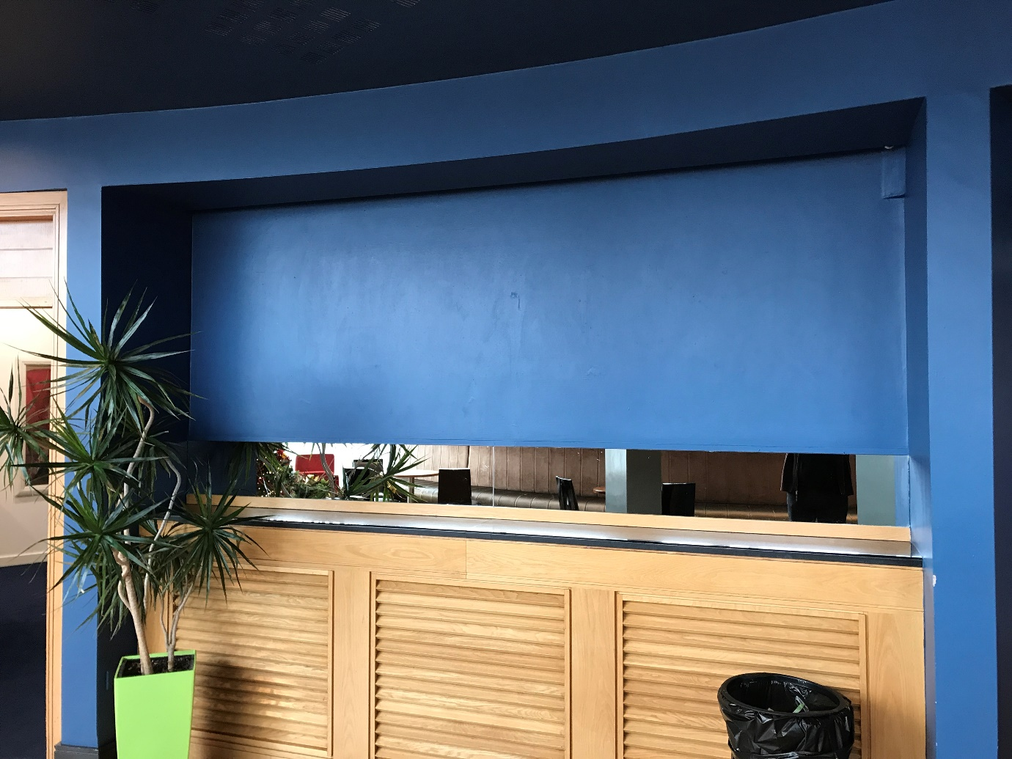
Recessed Section of Blue Angel Bar
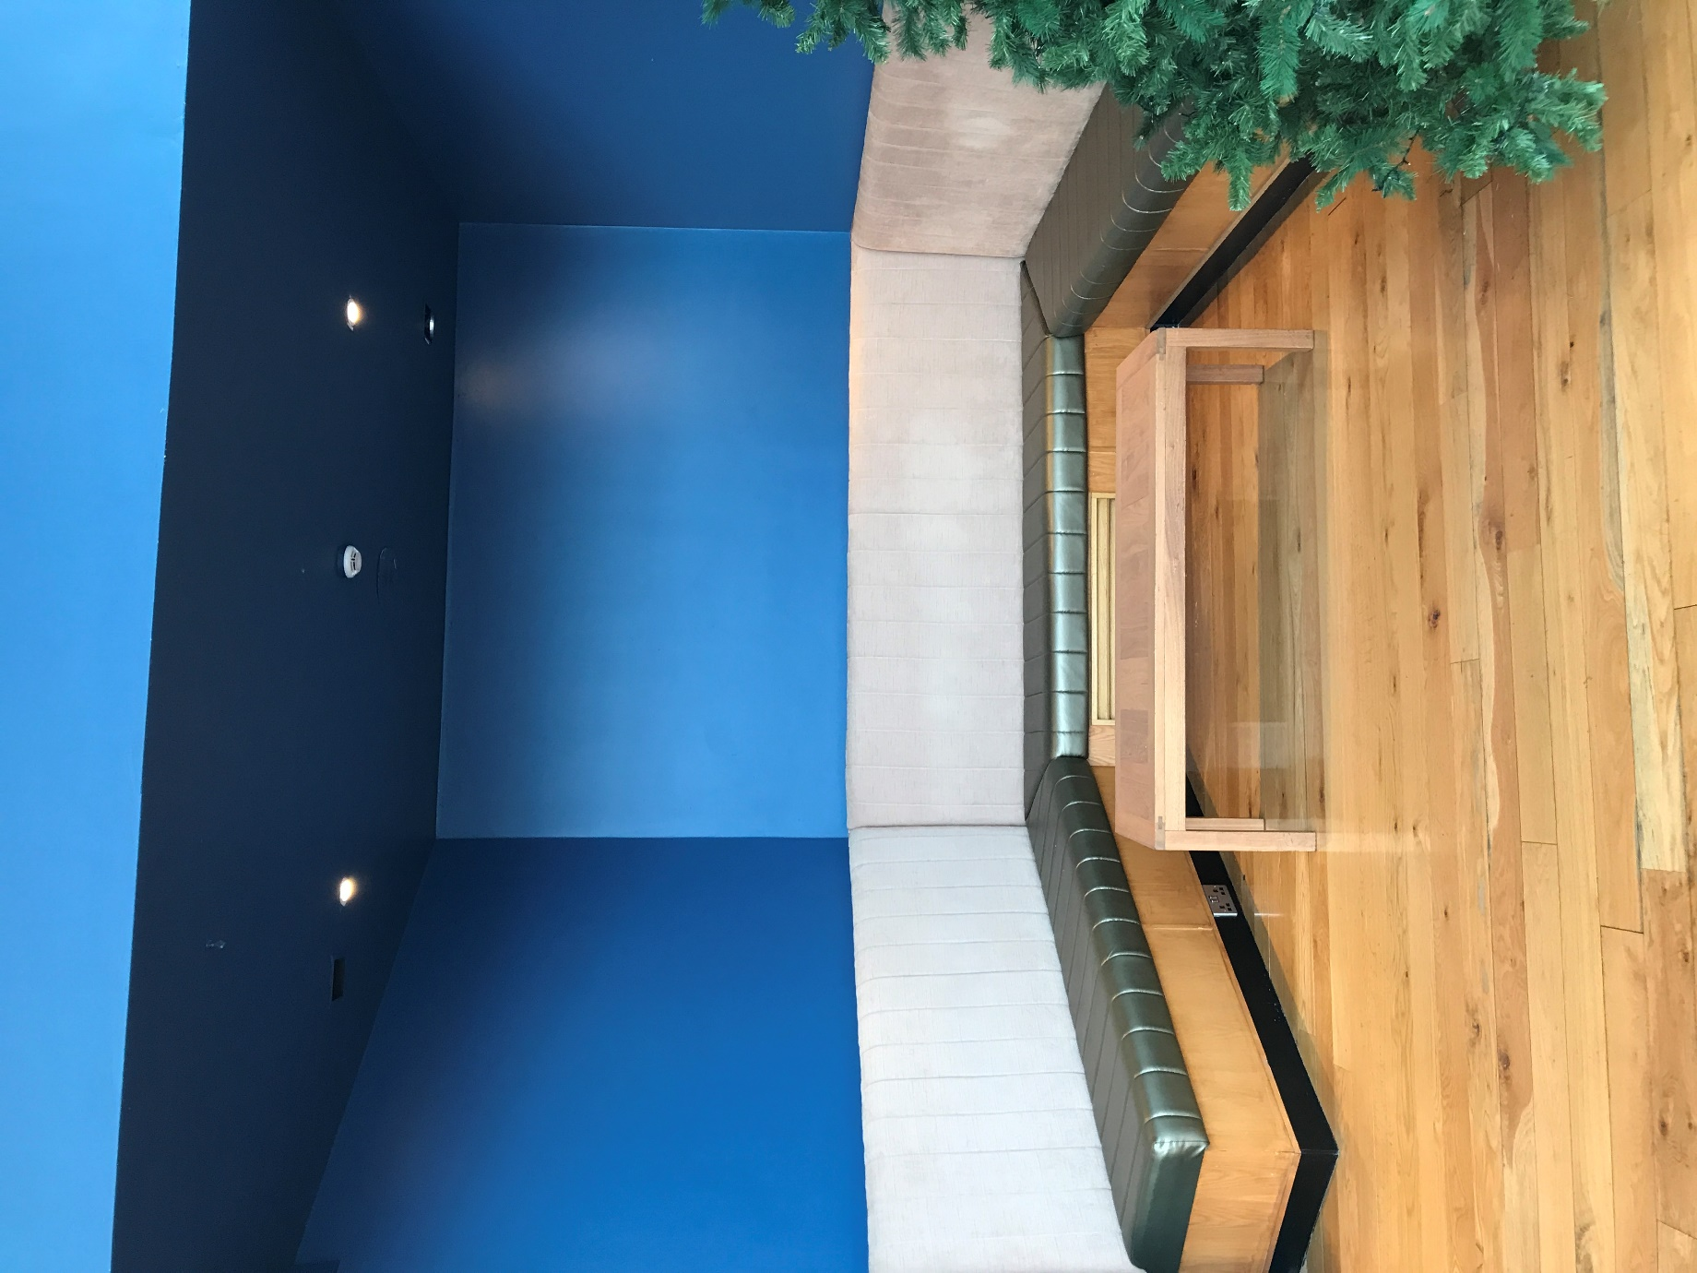
Alcove area in Blue Angel Bar

