Cahergal National School
Per Cent for Art Commission
Stage One Brief & Application Form
Budget: €17, 462.96
Deadline: 31st March 2023

Introduction to School
In Cahergal N.S. we pride ourselves in providing a warm and caring learning environment for our pupils, a place where they can grow as learners and as people. The school originally opened in 1952 on the existing site and this was replaced with a state of the art new 6 classroom school in 2017.
Ethos
We are a Catholic School under the Patronage of the Archdiocese of Tuam. The Christian values of love, forgiveness, kindness, and respect, permeate all areas of school life in Cahergal N.S. We welcome pupils and families of all faiths and none. We promote an atmosphere of inclusion and endeavour to nurture and cater for the different needs and capabilities of all our pupils. We believe in an attitude of supportive partnership with our parental body and the greater community.
The selected Per Cent for Art Commission for Cahergal N.S. will have to reflect this ethos in meaningful way.
Our Brief
Upon consultation with the pupils, staff and BOM the following are the main requirements for the submission are outlined below:
- For the creative process to be transparent
- To be participatory in nature and have a sensory element
- To involve the outdoor school environment
- To be a celebratory process
- To be reflective of the local area/history/culture
Aims for Cahergal NS commission under the Per Cent for Art Scheme:
To leave a legacy that can be appreciated by the next generation of children
To consider the outdoor school environment in an interactive, accessible and with a tactile element
To involve the children in the creative process

Locations
Please see attached to this document, photographs of the school building the school grounds, and a map of the school grounds. If selected for Stage 2 of the process, a mandatory site visit will be facilitated.
Participation
Participation from a number of student groups is required as part of the commission. This participation may involve students contributing directly to the artwork in some way. Artists will be required at Stage Two to describe the approach that they will take to participation and the rationale behind it.
The Commissioning Process:
The selection process will take the form of a two-stage open competition. It is open to all interested professional artists. Selection will be based on the information supplied, establishing the competence of the artists to carry out this commission. No designs or detailed proposals are required in Stage 1.

Stage 1
Artists are invited to express their interest in being considered for this project at the first stage of this commission. Artists may do this by completing the application form and a PDF of least 10 images of recent work with captions.
These may be submitted by email to info@cahergalns.ie no later than is 12 noon, 31 March 2023.

Selection Criteria Stage 1
- Strength of track record to date in creating a piece of public art
- Experience of working on similar projects
- Ability to reflect the spirit, ethos, history and cultural context of Cahergal N.S.
- Flexibility and adaptability
- Appreciation for the busy learning and working environment of the primary school
- Respect for the wishes of the school/committee overseeing the project

Stage 2
From the completed Stage 1 applications; a shortlist of artists will be selected by panel jury. This panel, whose decision is final, has the right to clarify any issue which may arise in the course of selection.

Stage 2 short listed artists will be paid a concept development fee to work on a detailed proposal for final selection. A further brief will be given and a site visit is expected at this stage.

Shortlisted artists will be provided with a concept development fee of €300 to support them in undertaking a mandatory site visit and developing a detailed proposal for Stage Two. Artists selected to proceed to Stage Two may be provided with a more detailed brief outlining submission requirements. The award of the commission will be made following receipt of the Stage 2 applications.

The commissioned artist will be expected to complete Garda Vetting and must provide the following:

●Tax clearance certificate and/or artist exemption certificate

●Evidence of appropriate insurance

Please note that Cahergal N.S. reserves the right to commission at Stage One, or to shortlist for the Stage Two process, or indeed not to commission from entries received and to re-advertise, direct invite, direct commission or to select more than one artist / collective and to divide the budget.

Selection Panel

The selection panel will consist of members of the Public Art Committee including members of Cahergal N.S. staff, Board of Management, children’s representatives, and one professional artist.

Selection Criteria for Stage 2

●Ability to carry out the project

●Ability to work with a professional brief within a specific time-frame

●Feasibility of delivering the commission within the proposed budget

●Durability and implications for future maintenance where appropriate

●Potential of the proposed project / artwork to have an enduring legacy

●Artistic merit of proposed artwork / project

●Quality, clarity and practicality of proposal

●Innovation of concept / proposal / idea

●Integration of project with the school building, community and / or environment

●Potential of the proposed project / artwork to meaningfully engage the whole school community

Timeline

31st March 2023 - Deadline for Stage 1 Submissions

Mid-April 2023 - Selection panel will shortlist a number of artists to proceed to Stage 2

Late-April 2023 - (Mandatory) site visit for shortlisted artists.

Mid-June 2023 - Deadline for Stage 2 Submissions

Late June 2023 - Selection panel meet and selected artist is commissioned.

September 2023 - Commencement of commission.

February 2024 - Deadline for completion of commission

Site Location:
Cahergal N.S., Cahergal, Tuam, Co. Galway.

Budget:
The total budget for the project is €17,462.96 including V.A.T. This includes the costs of materials, artist’s fees, design development, artists’ insurance, supply and installation, travel, and any other costs incurred in the production of the artwork/s. The artist will be responsible for meeting all of these costs out of the total budget allocated.

Site Visits:
Site visits can be arranged for shortlisted artists at Stage 2 of the commissioning process.

Queries:
Applicants can make enquiries regarding the commission to info@cahergalns.ie or by telephone 093 49364. You will find out more about our school at www.cahergalns.ie

Guidelines:
It is recommended that you read the guidelines and supply supporting documentation and material as requested.

1. Include a current CV

2. Include the best examples and reproductions of your work/working practice. Please do not send original artworks.

3. Please complete the application form clearly in black ink or type.

4. Include a stamped addressed envelope for return of material.

5. Keep a copy of your application for reference purposes

Pictures of the school (more available on www.cahergalns.ie)
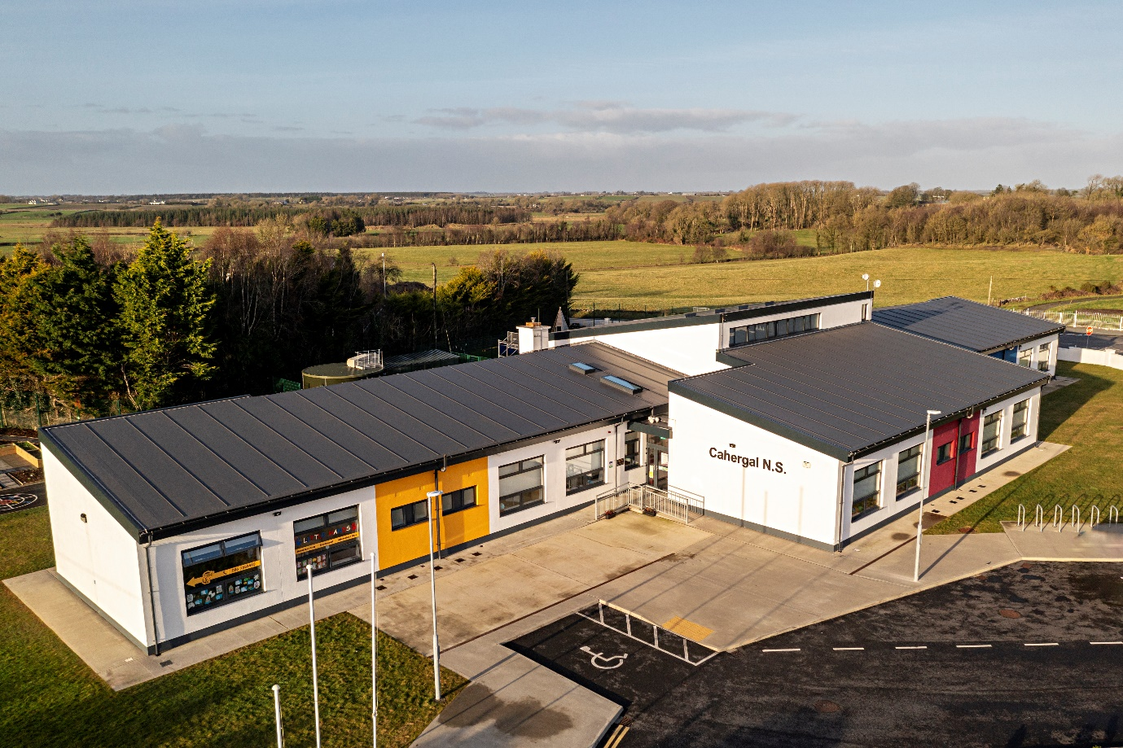

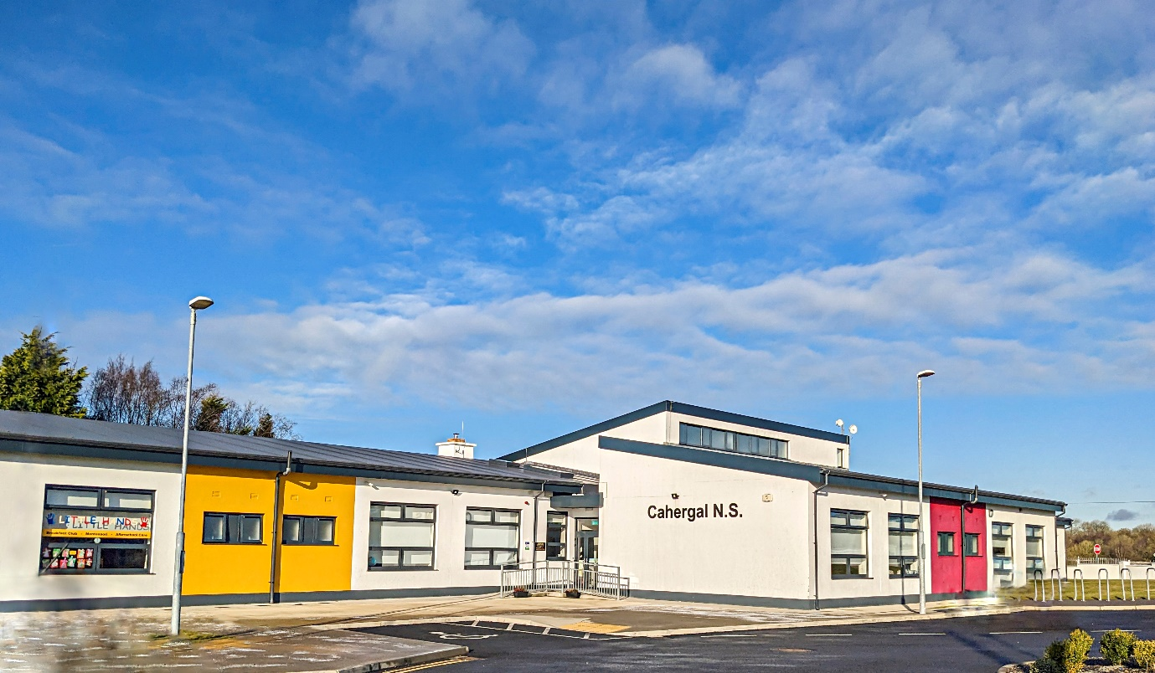

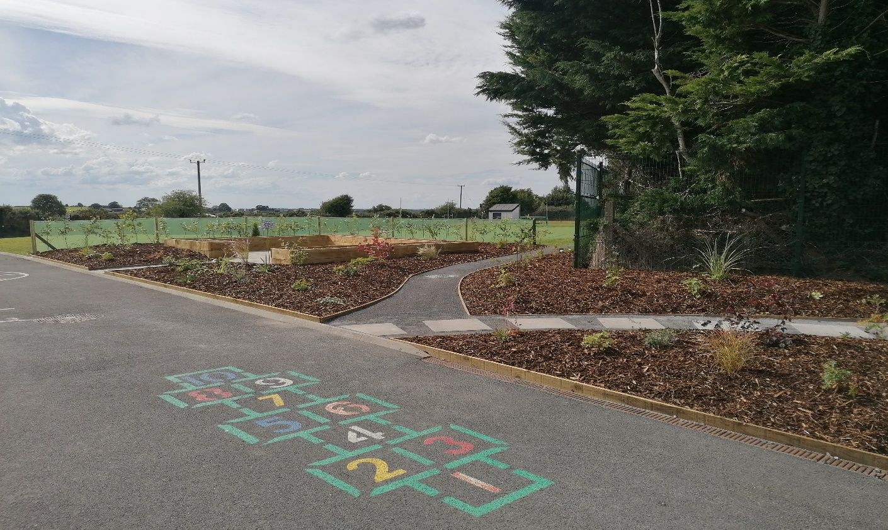

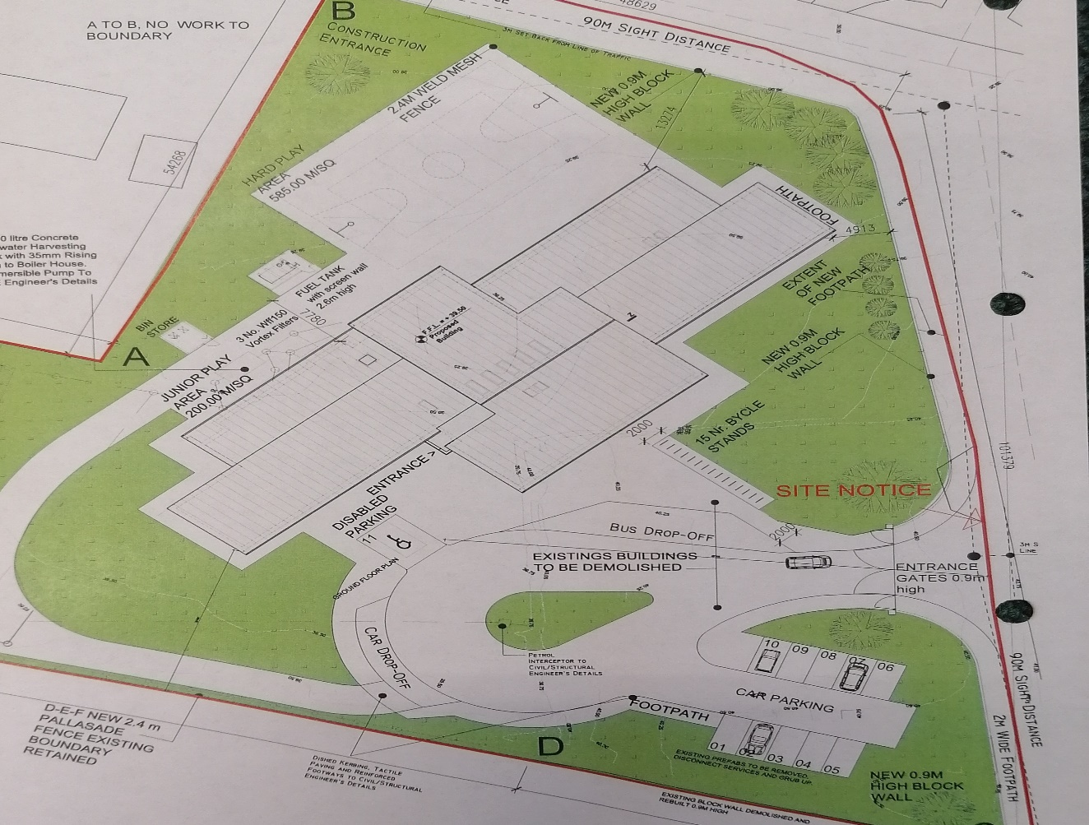
Percent for Art Commission
Cahergal National School

Stage 1 – Application Form

Name of Artist: __________________________________________________

Contact Address: (please note all correspondence will be sent to this address)

___________________________________________________________________

___________________________________________________________________

Telephone/Mobile:__________________email: ____________________________

1) Please give short description of your art practice (max 50 words):

2) Artists are asked to submit the following:

a. Detailed Curriculum Vitae

b. List of previous relevant projects or commissions, cost, time scale to deliver, list of specialist or other contractors engaged by the artist in connection with the completion of these installations

c. Visuals of previous work

d. References and contact details

e. Confirmation that if successful the artist is ready to submit current Tax Clearance Certificate and provide insurances. This confirmation is mandatory.

3) Supporting Documentation:

To assist in the assessment of your application, supporting documentation should be included and should be submitted and it must be clearly labelled:

Supporting documentation | Number of  Items attached | Enclosed  (please tick)
CV
Other, please specify

Freedom of information:
Applicants completing this form should note that information provided to The Principal, Cahergal N.S., Cahergal, Tuam Co. Galway may be disclosed in response to a request made under the Freedom of Information Act (1997 and 2003). Every effort will be made to protect client confidentiality.

Garda Vetting:
The successful artist will be subject to Garda vetting procedures.

General Information:
Where did you hear about the competition (please tick to indicate):

Local Authority Arts Office Website Local Media

VAI Other

If other, please specify_________________________________________________

Declaration

I have read the award conditions, agree to be bound by them, and certify that the information in this application is correct to the best of my knowledge.

Signed ____________________________________

Date ____________________________________

This application form should be returned by email to:

info@cahergalns.ie

Closing date for the receipt of completed applications is 12 noon, 23rd March 2023

Please note that applications received after the closing date and time will not be accepted.

