**Stage 1 Brief for Public Art Contract**

**Ancient Connections**

**2020-2022**

|  |
| --- |
| 1. **Introduction** |

Pembrokeshire County Council, on behalf of the Wexford/Pembrokeshire EU funded arts, heritage and tourism project *Ancient Connections*, wish to appoint an artist or artists to create two new connected pieces of public art, one in Ferns and one in St Davids.

Proposals are invited for the design and creation of both artworks, which must be linked to each other in some way. Links can be either visual, in terms of design echoes, conceptual in terms of themes or approach, or linked in other creative ways proposed by the artist/s. Proposals from individual artists, artist collectives, or artistic cross-border collaborations are welcomed, however **proposals for just one of the artworks in one location will not be accepted.** While artist collaborations are welcome, **one artist or company must be named as the lead contractor**, and all communication during the tendering process will be undertaken with them.

The maximum budget available is €175,000 to cover all costs including artists’ fees and expenses, engineering, materials, costs relating to permissions, eg. planning permission, documentation and installation. The two artworks, one in Ferns and one in St Davids should have equal budget allocation and equivalent status and impact.

The contract will be awarded in two stages. Stage 1 is an Open Call for Expressions of Interest. Applicants for Stage 1 are invited to present an **artistic approach** to the brief, **not a design proposal**. From these submissions, a shortlist of five artists will be selected by a cross-border panel based on the scoring process outlined below. These artists will be invited to make site visits to both locations, meet community groups and planning specialists and develop designs and a costed proposal. A fee of €1500 will be paid to these artists to include their time, travel expenses and accommodation. (NB. These fees are additional to the budget of €175,000. In the case of joint artists submissions the €1500 fee must be divided between the artists).

In the interests of transparency, ALL documents relating to Stage 1 and Stage 2 submissions are included in the tender documents from the outset. Appendices relating to planning and interpretation are included as an overview and are mainly suited to Stage 2 applicants. However, can be read if Stage 1 applicants feel they would benefit from this.

**Deadline for Stage 1 Expressions of Interest – Monday 21st September 5 pm**

|  |
| --- |
| 1. **Background** |

This contract is part of a wider cross-border heritage and arts programme called *Ancient Connections*. The project is funded by ERDF (European Rural Development Fund) led by Pembrokeshire County Council, with partners Wexford County Council, the Pembrokeshire Coast National Park Authority and Visit Wexford. The project runs from April 2019 – 2022/3

The project will help deliver Specific Objective 3 of the Ireland Wales Cross-Border Co-operation Programme 2017-20, i.e. *“To sustainably realise the potential of natural and cultural assets in increasing visitor numbers to coastal communities in the Programme area.”*

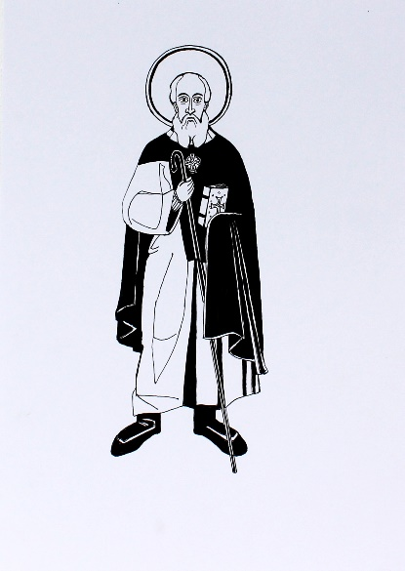 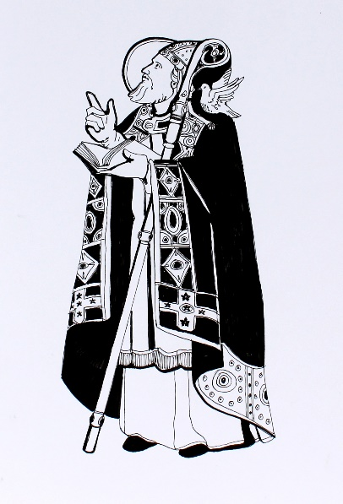

*St Aidan St David*

It will revive the ancient links between communities in Pembrokeshire and Wexford including shared heritage of St David and his pupil and protégé St Aidan. St David is the patron saint of Wales, commemorated in the city of St Davids where he spent much of his life, whilst St Aidan is closely associated with Wexford, in particular Ferns. One objective of the project is to motivate both communities to rediscover their shared heritage; to be a mentor for each other; and to share knowledge, experience and skills. Another is to use this shared heritage as a means of attracting people to the cross-border region, specifically to Wexford and to Pembrokeshire (both coastal communities), who would not otherwise do so.

The specific outcomes of the *Ancient Connections* project are:

* To create a cultural environment which puts these places on the map, making them a ‘must see’ during visits to South-East Ireland and West Wales.
* To develop a much stronger and integrated cross-border heritage story encouraging more visitors to both territories and the development of niche tourism business opportunities.
* To stimulate a significant increase in community involvement creating a stronger sense of identity and place and better tourism products which reinforces and utilises our shared cultural heritage opportunity, which again will drive more visitors.
* To increase visits in the shoulder months and thereby extend the season.

*Ancient Connections* is divided into eight work packages that cover a range of cultural heritage, arts, community and business initiatives (See **Appendix 1** for a summary of work packages). This Contract emerges from the package *Art Commissions and Access*. Also relevant to this contract are *Exploring a Shared Past* and *Destination Marketing.* The successful artist(s) will need to keep abreast of developments in these areas as they emerge and integrate findings by other contractors where appropriate in order to fulfil the overall project aims. Further information on each of these work packages and its relevance to the public art is given below:

**Exploring a Shared Past** has a number of distinct components that will be delivered by different teams of researchers and other specialists, which may be of relevance to artists developing ideas for the public artworks, including:

1. Researching and disseminating the core stories of connection
2. Geophysical Survey/Excavation of key sites in Wales and Ireland
3. Archaeological excavations at St Patricks Chapel, Whitesands, Pembrokeshire.
4. Establishment of Archaeological Field School (Ferns)
5. Historical and Folklore Surveys and training

Academic research around the stories of connection, community folklore gathering and a storyteller training scheme are key elements of this project. Story searches are already underway in the communities of North Pembrokeshire and North Wexford led by Abarta Heritage and Angharad Wynne. A draft literature review that outlines the main historical and folklore stories of connection has been compiled by Abarta Heritage and is included in **Appendix 2**

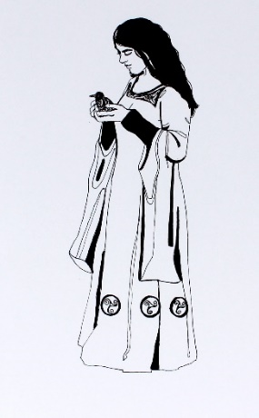 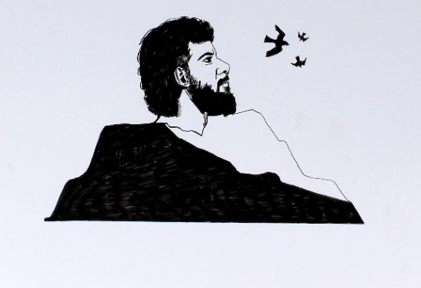 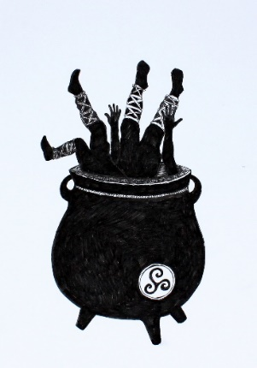

*Branwen, Bendigeidfran and the cauldron of rebirth*

In Pembrokeshireat Whitesands, the foundations of a stone-built chapel lie just beneath the surface of the turf. The 2014-16 excavations showed that this stone-built chapel overlies a cemetery dating from the 8th century to the 12th century, which is of great historical and archaeological importance. Phase one of the new excavations has already taken place in September 2019, with a report outlining the findings included in **Appendix 3.** Geophysical surveys are planned on a number of sites in the St Davids area**,** including the environs of St Davids Cathedral and the Chanters field, the environs of Mathry Church, the environs of Llanrhian Church, Capel yr Hen Fynwent, the environs of St Justinian’s Chapel.

In Wexford, geophysical surveys will concentrate on Ferns and the surrounding area including Kilcannon and Killabeg where there are possible monasteries dedicated to St Aidan and the ecclesiastical enclosure at Ballyorley Upper. In June 2021 the Irish Archaeology Field School (IAFS) will launch a major archaeological research project at the site of St Aidan’s Monastery, Ferns, Co. Wexford. The project, established as a partnership between the IAFS, Ancient Connections (via Wexford County Council) and the local community, aims to assess one of the most historically significant, but hitherto relatively unassessed, Early Medieval sites in southeast Ireland. The site is a multi-period complex, originally founded by St Aidan at the turn of the 7th century, which also contains Early Medieval crosses and cross slabs, a twelfth century Augustinian Abbey (founded by the King of Leinster Diarmuid McMurrough), and thirteenth century medieval cathedral (Edan’s Cathedral) within its wider confines. The St Aidan’s Monastery project is centred on a major research excavation of both the 7th century monastery and a latter 12th century Augustinian Abbey, which hopes to draw the site into the town of Ferns as a ‘key heritage attraction’, in the process providing added economic and amenity value to the local community. See [www.iafs.ie/ferns/](http://www.iafs.ie/ferns/) for further details.

**Destination Marketing** is another key work package that links to this commission. Ancient Connections seeks to increase the number of overseas visitors, particularly during the shoulder months, to both regions through a number of strategies. It is anticipated that the public artworks in Ferns and St Davids will be instrumental in attracting more visitors.

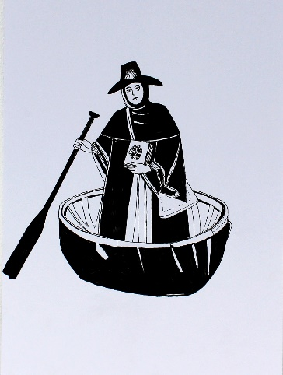 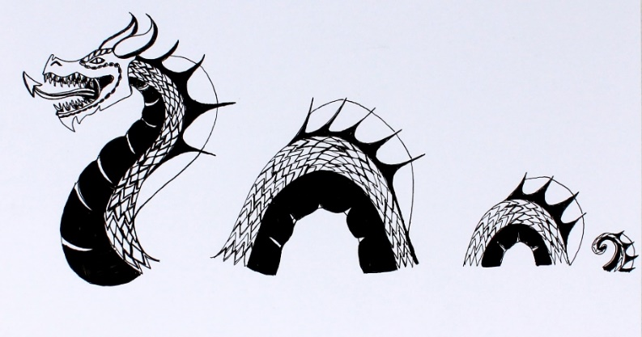

**Pilgrimage:** A feasibility study has been undertaken to explore the potential for promoting a pilgrimage route between Ferns and St Davids. To further explore how this might be experienced in practice, an experimental pilgrimage – *Creative Camino* – is taking place in May 2021. A group of 14 pilgrims including artists, community members, a travel writer, and a filmmaker will be making the journey on foot. This empirical research will enable the team to establish the viability of promoting a route that would attract overseas tourists onto both guided and self-guided tours. (NB It is beyond the scope of the project to carry out significant access work on the proposed route, although this may happen at a later stage if further funds can be sourced). For the purposes of this contract, it is important to know that pilgrimage is an important theme within the project and proposals that connect to pilgrimage are welcome.

(*All illustrations by Sarah Williams*)

|  |
| --- |
| 1. **Public Art Contract Context** |

Two public art consultations took place in November 2019, one in Ferns and one in St Davids. The key findings from these consultations were that there was a strong desire for the two artworks to be linked to each other and to be created from environmentally sustainable materials. In Ferns there was a strong desire for a permanent artwork (rather than a temporary work installed for a few years) in St Davids, just under half of those consulted preferred the idea of a permanent work, and the other half were open to either a permanent or temporary artwork. There was a strong desire for community involvement in the evolving process and for artworks that are accessible for everyone, engaging and interactive.

Detailed information about these consultations and the design boards that participants created in response to the question ‘What does St Davids mean to you? / What does Ferns mean to you?’ are included in **Appendix 4 & 5**

Photos of key tourist attractions, sites of interest and a list of relevant links are included for Ferns in **Appendix 18** and for St Davids in **Appendix 14**

**Sites**

In Ferns, a number of possible sites within the village have been identified, some publically owned and some privately owned. Discussions are underway with relevant landowners. Shortlisted artists will be able to view the potential sites and permissions will be sought once preferred sites have been identified.

In St Davids, a number of possible sites have been identified within the grounds of St Davids Cathedral: See site maps **Appendix 7** and photographs **Appendix 8.** In addition, a location(s) on the Pembrokeshire Coastal path would be considered, however there are significant restrictions on what would be acceptable here (see Stage 2 brief for further information).

**Planning Consent and permissions**

Designs created by shortlisted artists will be subject to planning consents and regulations. Please note that there are a number of Scheduled Monuments and Listed Buildings of national importance within the St David’s Cathedral Close. As a result of their protected status, any proposals impacting the setting of these designated assets would first require approval by the consenting authority, in this instance Cadw ([www.cadw.gov.wales](http://www.cadw.gov.wales)), before seeking any necessary planning consents from Pembrokeshire Coast National Park Authority. In addition, sited artworks must not visually obscure an important view of the Cathedral or other important buildings such as The Bishops Palace. Shortlisted artists will have the opportunity to meet with the diocesan or Cathedral Archaeologist or a Cadw representative. The Listed Building Officer for PCNPA may also be able to advise if it impacts on the setting of any listed buildings within the Cathedral complex.

|  |
| --- |
| 1. **The Commission: Objectives, Target Audiences and Deliverables** |

Please bear in mind the following guidelines when making an Expression of Interest:

1. **Themes**

Proposals are welcomed that explore and weave together some of the following themes:

1. Shared stories and heritage between the two regions
2. Pilgrimage and journeying in the context of these two locations.
3. The significance of the early Saints particularly St Non, St David and St Aidan.
4. Environmental significance and landscape echoes of these two regions
5. **Materials and structure**
6. The Artworks must be designed using at least 50% sustainable materials (eg wood, stone, glass, plants) and sustainable construction methods. Non-sustainable materials can be used for structural purposes where required.
7. Proposals for a series of linked artworks that form a trail will be considered as well as proposals for earthworks that connect to larger environments and include planting or environments for non-human inhabitants.
8. Permanent or semi-permanent artworks will be considered in both locations with an expectation that if the latter, this would last for a minimum of 5 years. Artworks that are designed to erode naturally over 5 years or more will also be considered.
9. Low maintenance artworks are required. Depending on the final locations, the maintenance may be carried out by the land owner or Local Authority. In the case of projects that involve planting, it may be possible to engage community volunteers to carry out ongoing maintenance.

**Objectives**

1. To create high quality legacy artworks that are inspiring and embrace the stories of connection linking North Pembrokeshire and North Wexford
2. To strengthen and empower local communities and encourage greater sense of identity linked to place.
3. To encourage greater cross-border travel through a desire to experience both artworks
4. To encourage overseas visitors to both regions

**Target Audience**

This would be multi-tiered and include:

1. The local communities of all age groups in both Ferns and St Davids and more widely in Pembrokeshire and County Wexford who will regularly encounter the artworks in their daily lives.
2. UK and Irish visitors to both territories who are encouraged to visit the other region in order to fully understand the shared history and heritage.
3. International visitors who will be encouraged to visit one or both regions particularly in the shoulder months.

**Deliverables**

The final successful artist/s is expected to deliver the following within the suggested timescales:

1. Design of two low maintenance pieces of public art, one permanent piece in or around Ferns, Wexford and one permanent or semi-permanent piece in or around St Davids, Pembrokeshire that link visually or conceptually.
2. Engage in significant community consultation supported by the Ancient Connections team.
3. Comply with Welsh Language Measure Act (any text included in St Davids artwork must be bilingual). Similar consideration should be given to Irish language (ant text included in the artwork must be bilingual)
4. Collaborate with the Ancient Connections team to secure planning consent where needed, and if necessary adjust designs accordingly.
5. Undertake or commission any required engineering investigations or plans and liaise closely with engineers during construction.
6. Oversee or undertake the construction of the artworks including any subcontractors engaged.
7. Oversee the installation of the artworks including managing subcontractors and lead on troubleshooting.
8. Document the process and the final installed artworks for legacy and publicity purposes and share documentation with the project team.
9. Participate in Ancient Connections talks and events that are relevant.
10. Attend official opening of both artworks and give a public speech in both regions.
11. Cooperate with marketing contractor to ensure maximum publicity coverage, possibly including participating in a to-camera interview.
12. Rectify any defects not due to vandalism or extreme weather conditions for 1 year after installation (5% of the fee will be retained for 1 year).
13. Hand over responsibility for the artworks to owners (either PCC and WCC or with agreement to landowners where the artworks are sited) with written care and maintenance instructions and face-to-face meetings if required.

|  |
| --- |
| 1. **Artist Specification** |

The shortlisted artists must have professional indemnity and public liability insurance (or be able to secure this before a contract is issued).

1. Professional indemnity insurance to a minimum value of £250,000
2. Public Liability insurance to a minimum value of £5,000,000

The shortlisted artist/s will be able to demonstrate:

1. That they can EITHER work successfully across the two territories OR collaborate with another artist/s in the other region.
2. A track-record of high quality public art commissions that bears relevance to the scope of this project.
3. A track-record of consulting with communities in the production of public art
4. Public recognition for previous public artworks produced.

|  |
| --- |
| **6. Timescales** |

* Closing date for Stage 1 Expressions of Interest Monday 21st September 2020 5 pm
* Shortlisted artists informed by Tuesday 6th October 2020
* Site visits Ferns and St Davids, meet communities and discuss ideas with site specialists between 12th and 23rd October 2021
* Designs and Stage 2 proposals submitted by November 30th
* Community consultation of the five shortlisted 5 proposals December 2020
* Panel 1 and 2 evaluation and scoring January 2021
* Clarification interviews January 2021
* Selection of artist/s January 2021
* Community engagement, and final design development Feb-April 2021
* Planning permissions sought if required (PCNPA and WCC and Cadw). Completion of any required Risk Assessments April-July 2021
* Manufacture of artworks July 2021-January 2022
* Installation of artworks November 2021 – February 2022
* Artworks **must be completed by** 1st March 2022
* Public launches April 2022
* Hand over April 2023

**Please note that the timescales indicated are subject to change depending on the ongoing COVID-19 crisis and other factors such as delays due to planning issues. The selected artist is expected to collaborate with the project team to agree new timescales if necessary.**

|  |
| --- |
| 1. **Tendering Criteria** |

For your Expression of Interest, you will need to answer the following questions:

1. **What would be your artistic approach to this commission?** Please outline your initial thoughts on how you would approach the project, explain artistic processes, themes, materials used in your work to date that are of relevance in developing a proposal that links St Davids with Ferns. Please state whether you would work alone or in collaboration with other named artist/s. This is **NOT** a design proposal(max 800 words)
2. **How have you engaged/consulted with community groups in previous projects?** (max 400 words)
3. **What relevant experience and qualifications do you have that would ensure that you could deliver this project to a high standard?** Please include information regarding all artist/s and any partners or sub-contractors you are proposing to work with. **Please collate into one document** and include:
4. **An up to date CV** no more than 3 pages long (if this is a collaborative proposal, include CVs for each artist).
5. **Up to 10 images of previous public artworks** with titles, locations, dates and any other relevant details. (10 images in total – if collaboration is involved, please include some images by each artist). This should represent the broad spectrum of your experience and the range of different sites that you have engaged with.
6. **Online links to previous public artworks** or films of the artworks. (One page A4 maximum)
7. **Copies of any professional reviews**, newspaper articles, links to online reviews, audience or community comments and feedback about previous public artworks that you have designed.

|  |
| --- |
| 1. **Assessment criteria** |

Tenders will be scored on the following basis:

|  |  |  |
| --- | --- | --- |
| **Criteria** | **Weighting** | **Notes** |
| Quality and appropriateness of artistic approach outlined in Expression of Interest | 30% | Refer to Question 1 in Tendering Criteria |
| Track record of engaging with communities in public art projects | 20% | Refer to Question 2 in Tendering Criteria |
| Relevant experience & Qualifications | 50% | Refer to Questions 3 in Tendering Criteria |

Evaluation and scoring of the Stage 1 applications will be carried out by an equally balanced cross-border panel of specialists including the Ancient Connections project team, Wexford County Council’s Arts Officer, public art specialists based in each region. The panel will review the submissions separately, then meet online to discuss and score them collectively using the above criteria.

**Closing date for submission Stage 1 - Monday 21st September**

Online applications only through Etender Wales Bravo Solution.

<https://etenderwales.bravosolution.co.uk/web/login.shtml>

**All enquiries / clarification questions MUST be through the Etender Wales portal.**

|  |
| --- |
| 1. **Credit** |

This project is part-funded by the European Regional Development Fund through the Ireland Wales Co-operation Programme 2014 – 2020. This text and the logos below should appear on all reports and any other outcomes from this contract, e.g. presentations, publicity etc.

